F i r e ● B y ● F r i c t i o n
By: Arthur Lagler and Chris Myers

I. What Kind of Wood
- Must be non-resinous wood. (Non-coniferous tree)
- Can be:
  - Red Elm
  - Cottonwood
  - Poplar
  - Dogwood
  - Basswood
  - Lombardy Poplar
  - Aspen
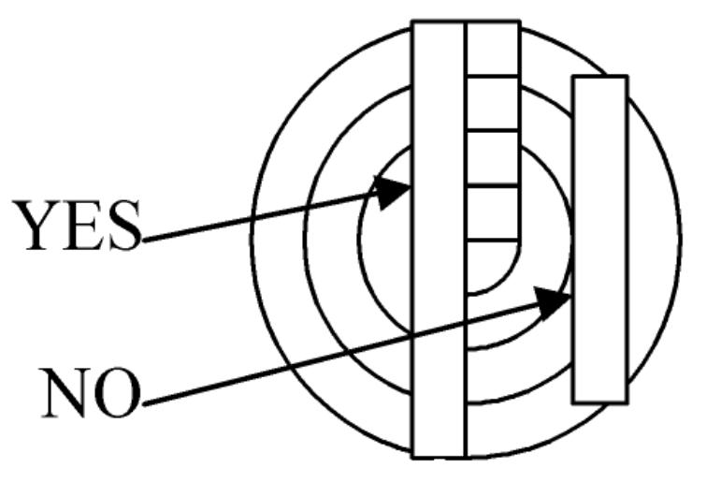
- The wood must be dead (no sap) and dried out. When you hit it, it should ring not thud. A dead tree has no small twigs.
- How will you recognize the species when it is dead and without bark?
  - Find living trees of the kind you want.
  - Look for dead “similar” trees in the area. Chop into wood to look at grain-color.
  - Have samples of the wood you are looking for.
- Pick out a section of trunk or limb that is strait and the bark has no blemishes, this will make straight knot free boards and spindles.
- Cut your wood 3 or 4 inches longer than you need, so any bad ends can be cut off later.
- Your spindle must be at least as long as the distance from the floor to the back of your knee. It can be cut shorter if necessary, but can’t be made longer later.

II. Making your friction set
- The spindle and board are best when made from the same piece of wood. That way you don’t have a hard piece that will glaze on a soft piece.
- They should be out of the same log not just the same kind of wood, for example Elm or Cottonwood from different sources are not the same.
- I like boards with vertical grain. Boards with flat grain tend to glaze.
- Split the wood by pounding your hand ax into the end of the log with another heavy piece of wood.
- Split your log down the center. Now split a slab one inch thick, this will be your board. Split off another slab to be split into spindles.
- You can make a good set from a piece of wood 1.5 or 2 inches in diameter. Indians made small sets.
- I prefer trunk wood.

III. Making Spindles
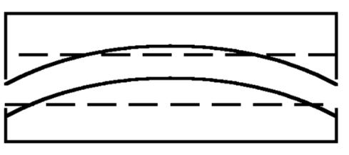
1. Chop the hollow side of the crooked spindle straight first.
2. Lay on flat side on a flat surface and scribe a straight line on the opposite side chop to the straight line.
- Do the same to the two remaining sides, to make a square spindle.
- Whittle the corners off to make 8 sides. (Not round)
- Make a ball end for the top and a slightly round end for the bottom.
- A crooked spindle will flip out of the board.
- It is easier to chop a board flat if your ax is ground sharp on one side only.

IV. Your Bow
1. Curved bow
  - There are two kinds of bows, curved and straight. The disadvantage of the curved bow is, it will bend on the “push” stroke, this loosens your bowstring, it will slip and the spindle will be only turning on the pull stroke.
  - But if the curved bow is very stiff this is less of a problem. A stiff curved bow is best.
  - The advantage of the curved bow is that if the string stretches and slips, you can move your hand up the bow, grab the string and pull it up against the bow this will tighten the string without stopping.
2. Straight Bow
    - The advantage of the straight bow is it pulls the same in “push” and “pull” stroke.
    - The disadvantage is, if the string stretches, you must stop to tighten it.
    - Another problem is, it must be strung at maximum tightness, and this makes it hard to put the spindle in, and is more likely to flip out of the board.
3. I like a very stiff curved bow.
4. The holes in your bow.
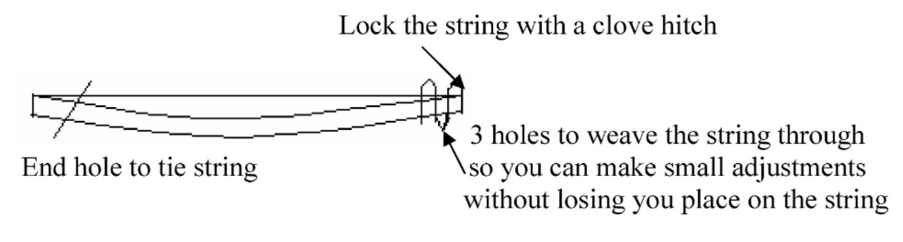

V. Your Top Bearing Thunder Bird or Head
- This part should be of very hard wood, you want it to glaze.
  - Oak
  - Hickory
  - Beech
  - Ironwood
  - Walnut
  - Stone
  - Baked Clay
- It should fit your hand and not set up to high on the spindle.
- The hole can be lubricated with jewelweed. This is the best. It is what the Indians used.
- Other plants will do. You can spit in the hole if it gets hot.

VI. The Bow String
- At one time a leather thong was used for the bow string.
- The best string I have found was WWII Parachute cords.
- You can get nylon cords that are braided on the outside with just straight fibers on the inside. They are almost as good as WWII cords; they lie flat “like a belt” and get more traction than a hard round cord.
- A big diameter string is all right but runs up and down the spindle more.

VII. Your Birds Nest
- The bird’s nest can be an actual nest, birds nest or mouse nest. They contain nitrates that make them burn good. Some have too much mud and won’t burn. It is also illegal to use bird’s nest.
- Material to make nest
  - Dry Grass
  - Cedar Bark
  - Binder Twine
  - Milk Weed Pods
- If material is too coarse your spark will break up, and fall through.
- If material is to fine it will burn like a cigarette.
- It is best to make a nest with a dense pad in the center to lay your spark on.
- Don’t Rush! Your spark will burn a long time.

VIII. Blowing it to a Flame
- Carefully lay spark in center of nest.
- Hold it up high, tilt it so heat goes up through part of the nest, and breathe softly on it to keep it alive. “Whisper to it”
- When more smoke comes you can blow harder or use the figure eight arm movement, until it burns into flame.
- Blowing too hard at first can burn the spark right through the nest.

IX. To Finish Your Board

With your knife make a dimple about 1.5 times the diameter of your spindle from the edge of the board.
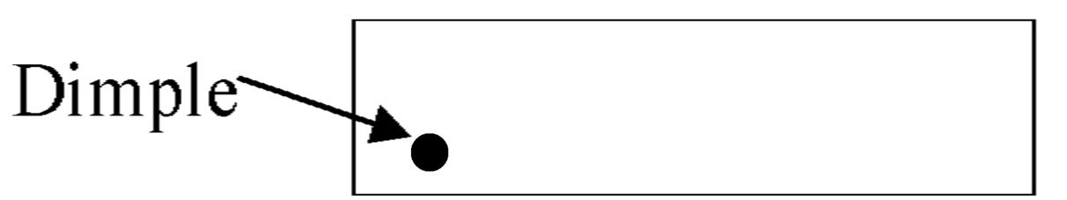

Use the bow to burn the spindle into the board.
- Now notch out the burned spot to the edge of the board.
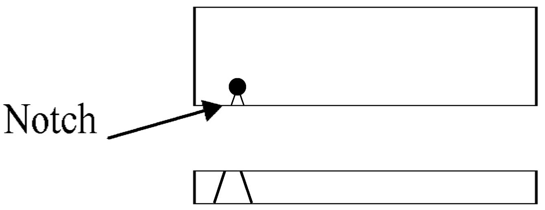
- Now pump out a spark!

